**KRUSHNA PATARE**

**(SOFTWARE TESTER)**

 Ahmedabad, India. [krushnapatare001@gmail.com](mailto:krushnapatare001@gmail.com) +919370526042

# PROFILE

A software test engineer with 3.3 years of experience, skilled in test planning, rigorous testing, and defect identification. Proficient in manual and automated testing, with a commitment to delivering reliable software and enhancing user experiences.

**TECHNICAL SKILLS**

**Java Jira Selenium WebDriver MS Office SQL Postman Maven Cucumber**

**Python Eclipse Jenkins GIT GitHub RestAssured TestNG JUnit**

# PROFESSIONAL SKILLS

**MANUAL TESTING:**

• Strong understanding of **Software Development Life Cycle** (SDLC) and **Software Testing Life Cycle** (STLC).  
• Hands-on experience in software testing, including Functional, Regression Testing, Retesting, Sanity, End to End Testing, GUI/UI Testing, Globalization Testing, Error handling, coverage Testing, Browser Compatibility Testing and various **Testing Techniques**.

• Actively participated in different **Agile** ceremonies.  
• Experienced in preparing and executing Test Cases using MS Excel.  
• Proficient in using **Jira** for test management and tracking the **Bug Life Cycle**.  
• Skilled in analyzing test results to ensure correct implementation of functionality.  
• Well-versed in various Software Testing Principles.  
• Design the **Traceability Matrix** to map Business Requirements with test Case.

• Basic knowledge of **SQL** Queries with DML and DDL commands..

**AUTOMATION TESTING:**

* Good Knowledge of **Core Java** concepts.
* Good Knowledge in **JAVA, OOPS Concept, Collections, Exceptions Handling, String Class**.
* Handled Dropdown, textbox, input field, multi-selections box, buttons, iframe, webtable, radio buttons, screenshot, mouse-keypad actions, **(Implicit, Explicit)** waits, **Screenshot Capture,** etc.
* Good Knowledge in writing **XPath expression** using different locators and **creating Page Factory** for all the pages.
* Read and write data from Excel file using **Apache POI** library & Read data form **properties** file.
* Used **AutoIt** for Uploading and downloading.
* Used **Slf4j** logging framework to record user interaction with webpage.
* Made reusable methods for user’s common interaction with browser thus webpage.
* Designed test methods that takes less time to make and handles and assertion errors flawlessly.
* Used **TestNG** framework with **annotations** and **assertions**.
* Used **extent report** for reporting handles by **listeners**.
* Performed parallel testing, cross-browser testing and data driven testing**(DDT).**
* Used **Eclipse** IDE, **Maven** build tool, **GIT** and **Jenkins** CI/CD tool for Timely execution.
* Knowledge in Performing **UI** Automation through **Selenium WebDriver** on browsers like **Edge, Firefox and Google chrome, etc.**

**API TESTING**

* Knowledge of Performing Manual Api Testing using **Postman** tool.
* Performed **CRUD operation** like Post, Get, Update, Delete using Postman.
* Knowledge of different Authentications like Basic, Oauth,etc.
* Proficient in Programming using **Java** and **API Automation Testing**.
* Knowledge in **RESTFUL** webservice testing using **RestAssured**.
* Validated JSON formatted data, different **Http Status Code**, Statusline, **Headers, Response Time, Response Body, Json Schema, etc.**
* Developed RestAssured Automation Framework with **Java + Testng + Maven.**
* Developed RestAssured Automation Framework with **Java + Cucumber + Junit + Maven.**
* Created **Feature File, Step Definition Class, Runner Class**, etc.

**WORK EXPERIENCE:**

**EXCEPTNAIRE TECHNOLOGIES LTD. (Pune, Maharashtra)**  **(Dec 2021 – Present)** **Designation**: Software Tester, **Department**: Quality Assurance

**Project 1:**

**Name of the project**: CONNECT US 2.0 Ticketing System (ERP Domain)

**Testing Approach**: Manual testing

**Project Description**: A ticketing system collects and manages all customer support interactions from different platforms, including social media. This management system enables IT support agents to route various types of tickets to the correct person, resource, or department to obtain the fastest resolution.

**Project 2:**

**Name of the project**: CONNECT US 2.0 Bill Checking (ERP Domain)

**Testing Approach:** Manual testing and Automation Testing

**Project Description:** The bill checking module is the billing process which is helpful in creating bills, payment details, approval process and the bill payments. The scope of the project to create the bill, bills are assigned based on the authority approval process automatically and the bill payments.

Roles and Responsibilities

* Understand and familiarize myself with the project requirements, specifications, and test plans.
* Learn the software testing process and methodologies used by the company.
* Attend training sessions on testing tools and techniques.
* Perform basic manual testing, including functional testing, user interface testing, and data validation testing.
* Document and report bugs or defects found during testing.
* Participate in team meetings and provide feedback on testing activities.
* Assist in creating and maintaining test cases and test scripts.
* Participate in test data preparation and environment setup activities.
* Conduct regression testing to ensure that new changes haven't introduced bugs in previously working features.
* Gain familiarity with automated testing tools and frameworks used by the team.
* Assist in executing automated test scripts and analyzing test results.
* Collaborate with developers to understand and troubleshoot defects.

# EDUCATION

* Bachelor of Engineering from AISSMS COE, Pune ,78%, 2021, Pune University (SPPU).
* Diploma from Government Polytechnic Pune, 77%, 2018, MSBTE.
* SSC (10th) from RHS, Ahmednagar, 93%, 2015.

# PERSONAL INFORMATION

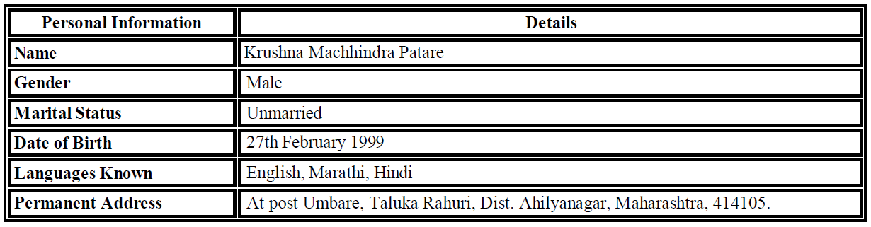

# DECLARATION

I hereby declare that the information provided in this resume is true and accurate to the best of my knowledge and belief.

Place:

Date: Signature: